# Features

**Updated Priorities:**

1. Reducing Human Error
2. Saving Time

* Scan based system -> Eliminates as much paper as possible
  + Takes priority over moving to another system

**Distribution:**

**Scan 1:** Upon completion of each box assembly, it will receive a UPC sticker for identification of its contents. Each skid is stacked with up to 50 boxes. Once a skid is complete, either we will scan each box or preferably scan one box and manually enter a quantity to be added to inventory. As the box assembly is added to inventory it will automatically deduct each unit of the assembly from our bulk inventory. (+1 box, -30 units)

**Scan 2:** As items are pulled from inventory to load onto a truck for distribution, they will be scanned and assigned an order #. This scan will deduct the item or assembly from inventory to create an invoice for the order #.

Scan 3: There are always items being returned to inventory after a distribution. The 3rd scan will simply be a “return” or “adjustment” on the order # so that it is not reflected on the invoice.

# Outside Foodbank Interviews

JFCS Food Bank

**What software does the food bank use to manage inventory?**

we do not do an inventory control; mainly because we have multiple vendors, multiple streams of available food (USDA commodities, donations with VAP, purchased...) and we push it through pretty quickly

**How does your organization keep track of different food items? Do you use a scanning system? If so, what scanning software is used?**

we track foods only through procurement and receiving and then once they are inhouse we use the eye

**What other technology is used within the organization to track and distribute food?**

excel spreadsheets, google sheets, a little bit of apricot CRM in regards to client preference

# Quickbooks Scanning Solution

(<https://quickbooks.intuit.com/desktop/enterprise/advanced-inventory/?cid=ppc_G_b_US_.QBES_US_GGL_Brand_Inventory_BMM_Search_Desktop._%2Bquickbooks%20%2Binventory_txt&rt_camp=QBES_US_GGL_Brand_Inventory_BMM_Search_Desktop&gclid=Cj0KCQiAs5eCBhCBARIsAEhk4r4vIXF4Bw5oAgZ0BXSdvnUlm8mId68BWpAnVm5_6BH9mHSCVPDIphYaAno7EALw_wcB&gclsrc=aw.ds>)

* Uses QuickBooks Desktop Mobile App to turn android into mobile scanners
* Automate receiving, accelerate your picking process, and reduce data entry errors.
* Send orders to workers on the floor, scan inventory, and transfer data wirelessly.
* Print barcode labels with sales prices* to give customers and employees the pricing information they need.
* Directly create invoice
* Only works with QuickBooks Enterprise (silver, gold, platinum)
  + Pricing: 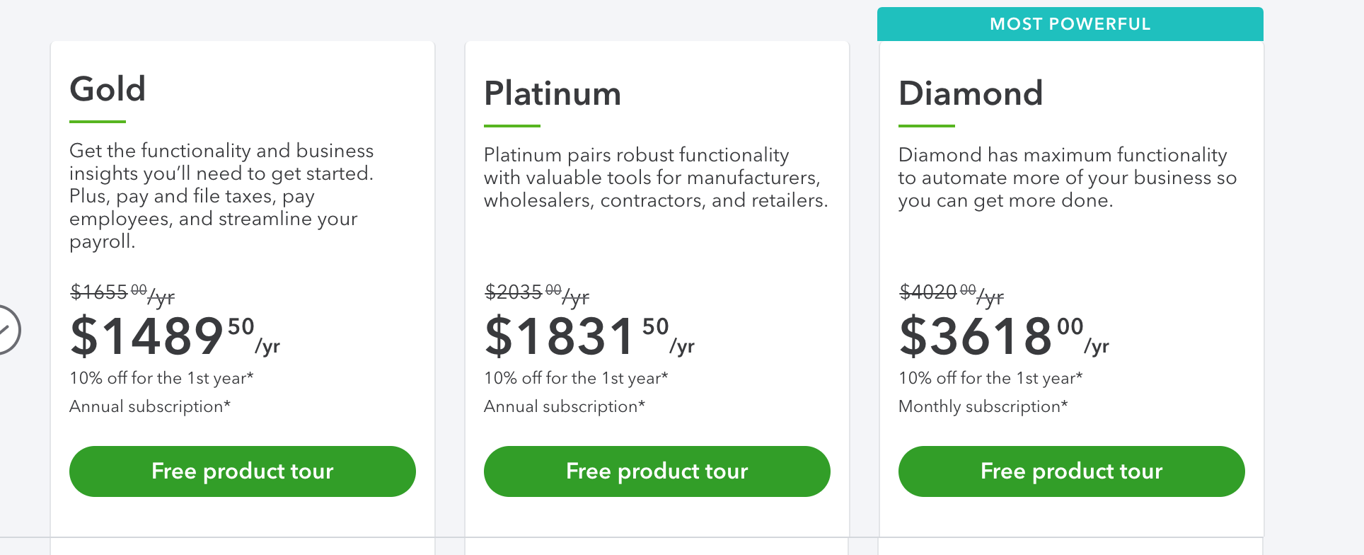

Steps to setup Quickbooks scanner

<https://quickbooks.intuit.com/learn-support/en-us/barcode-scanners/set-up-and-use-barcode-scanning-in-quickbooks-desktop/00/203410>

Tutorial: <https://www.youtube.com/watch?v=Zbb4eS5qJhs>

Pros:

-Able to integrate with current Quickbooks systems

-Directly create invoice

Cons:

-Pricing

-Needs Android 4.0 or higher for phone scanning

-Unable to directly link to inventory

# HandiFox Online

**3/20/2020 Update**

-a lot of non-profit org customers

-scanning directly linked to inventory

-creates invoice that is automatically linked to quickbooks inventory

-handifox desktop installed on mobile device using back camera as scanner, can also link separate scanner

-handifox desktop linked on desktop, lifetime license

-charged by # of mobile devices

-need 3 licenses $995

-Automatically linked to Quickbooks(desktop), mobile installation for scanner

-contact point for more questions: 321-373-0898

(<https://quickbooks.intuit.com/app/apps/appdetails/app-b7rstqpjjb/en-us/>)

Features:

- Scan the barcodes to confirm receipt of the correct items, sending the results over to QuickBooks. Generate PO’s to replenish inventory for inventory sites.

- Do inventory counts and move your inventory from one location to another, right on your mobile devices

-Use Android devices to scan barcodes to confirm shipments are correct and to print packing slips.

- Invoices automatically created based on the picking and packing scans

- Perform field sales, check inventory levels for items, work with sales transactions on the mobile device, process payments, capture customer signatures

Pricing:

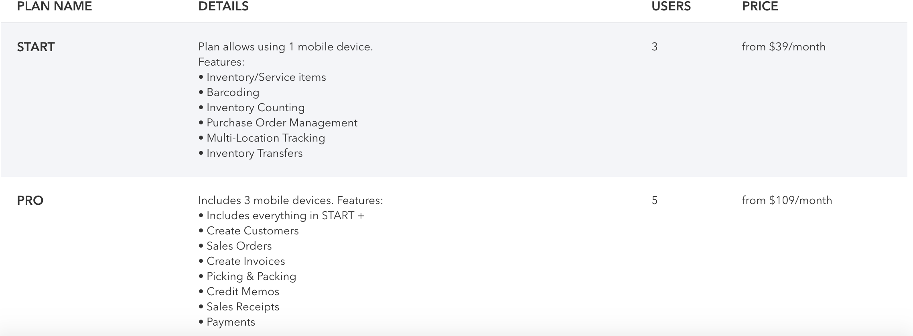

Pros:

-Easy to use

-Top rated application

-Free trial option

-Compatible w/ QuickBooks

Cons:

-Price

-Only compatible with Android

# Standalone software system

*Ruby on Rails application*

Software Problems / steps to consider:

* Parallel transactions. When two paid employees are attempting to update the values of inventory stock read/write locks may cause the values to be improperly updated
  + Need to lock transaction
* API for UPC code reading
* Send information from the handheld scanning device to the system so values can be updated. Essentially a transaction is requested via the scanner and needs to tell our system.
* Convert values into customizable report that can be exported as CSV

*Mobile App*

Software problems / steps to consider:

* Need to learn how to create mobile application and deploy it (none of us have experience)
* Need to integrate the existing upc camera scanning software into the applications
* May have compatibility issues depending on phone type